Skewness: Skewness measures the direction and degree of asymmetry in a dataset's distribution. A positive skew has a long right tail, a negative skew has a long left tail, and zero skew indicates a symmetric distribution. Statistical measure that tells us whether a dataset is symmetrical or tilted (skewed) to one side.

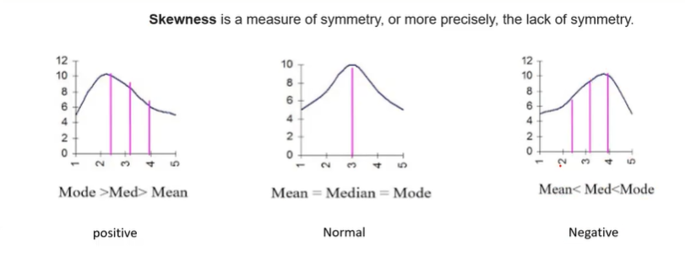

In a histogram:
- If the bars are evenly balanced around the center, the data is symmetric.
- If one side has a longer tail than the other, the data is skewed.

Types of Skewness
1. Symmetric Distribution (Skewness ≈ 0) - Normal
- The left and right sides are nearly identical.
- Mean, median, and mode are approximately equal.
Example:
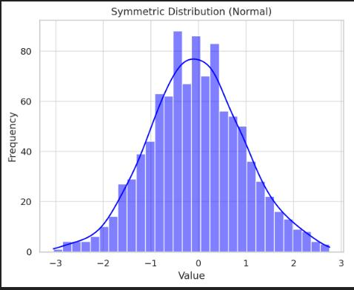
Relationship: Mean = Median = Mode

2. Positive Skew (Right-Skewed)
The tail extends toward the right because a few very large values pull the distribution in that direction.
Example:
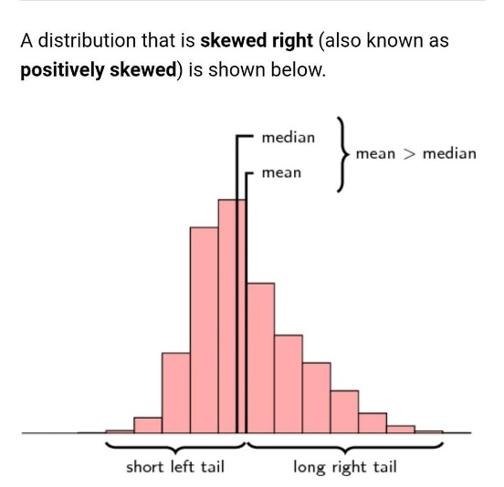
Relationship: Mean > Median > Mode
Example dataset: 20, 22, 23, 24, 25, 26, 28, 90
Inference: Most values are between 20 and 30, but the value 90 pulls the mean upward.

3. Negative Skew (Left-Skewed)
The tail extends toward the left because a few very small values pull the distribution in that direction.
Example:
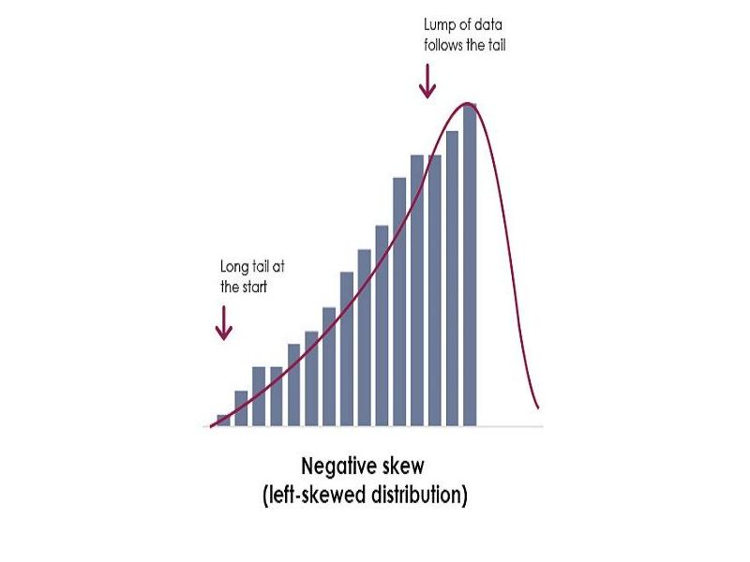
Relationship: Mean < Median < Mode
Example dataset: 5, 60, 62, 63, 64, 65, 66, 68
Inference: Most values are around 60–70, but the value 5 pulls the mean downward.

Real-Life Example: Student Salaries
Suppose placement salaries are: ₹2.5L, ₹2.6L, ₹2.7L, ₹2.8L, ₹2.9L, ₹3.0L, ₹12L
Most students receive salaries around ₹2.5–3 lakh, but one student receives ₹12 lakh.
- The histogram will have a long tail to the right.
- The mean salary becomes much higher than the median.
- This is positive (right) skewness.

Importance of Skewness:
- Helps identify whether data is normally distributed.
- Indicates the presence of outliers.
- Helps choose appropriate statistical measures: For highly skewed data, the median is often a better measure of central tendency than the mean.

